Online startup showcase website
WEEK 1
PROGRAM-1

Design a simple static HTML web page using:
Ordered lists
Unordered lists
Tables Display and
maintain Online startup showcase website

Program 1:
Starup showcase
<!DOCTYPE html>
<html>
<head>
<title>Online Startup Showcase</title>

<style>
body {
margin: 0;
font-family: Arial, Helvetica, sans-serif;
background: linear-gradient(to right, #4e73df, #1cc88a);
color: #333;
}

h1 {
text-align: center;
padding: 20px;
color: white;
background-color: #2e59d9;
margin: 0;
letter-spacing: 2px;
}

.container {
width: 85%;
margin: 30px auto;
background-color: white;
padding: 25px;
border-radius: 10px;
box-shadow: 0px 5px 15px rgba(0,0,0,0.3);
}

h2 {
color: #4e73df;
border-bottom: 2px solid #1cc88a;
padding-bottom: 5px;
}

ol li {
padding: 6px;
font-weight: bold;
}

ul li {
padding: 6px;
}

table {
width: 100%;
border-collapse: collapse;
margin-top: 20px;
}

th {
background-color: #1cc88a;
color: white;
padding: 10px;
}

td {
padding: 10px;
text-align: center;
}

tr:nth-child(even) {
background-color: #f2f2f2;
}

tr:hover {
background-color: #d4edda;
}

.footer {
text-align: center;
padding: 15px;
color: white;
background-color: #2e59d9;
margin-top: 30px;
}
</style>

</head>

<body>

<h1>ONLINE STARTUP SHOWCASE PLATFORM</h1>

<div class="container">

<h2>Steps to Submit Your Startup</h2>
<ol>
<li>Register your account</li>
<li>Login to dashboard</li>
<li>Fill startup details</li>
<li>Upload pitch deck</li>
<li>Submit for review</li>
</ol>

<h2>Startup Categories</h2>
<ul>
<li>FinTech</li>
<li>HealthTech</li>
<li>EdTech</li>
<li>AI & Machine Learning</li>
<li>E-Commerce</li>
</ul>

<h2 style="text-align:center;">Featured Startups</h2>

<table border="1">
<tr>
<th>Startup ID</th>
<th>Startup Name</th>
<th>Founder</th>
<th>Category</th>
<th>Funding Stage</th>
</tr>

<tr>
<td>101</td>
<td>QuickPay</td>
<td>Arun Kumar</td>
<td>FinTech</td>
<td>Seed</td>
</tr>

<tr>
<td>102</td>
<td>MediTrack</td>
<td>Priya Sharma</td>
<td>HealthTech</td>
<td>Series A</td>
</tr>

<tr>
<td>103</td>
<td>LearnX</td>
<td>Rahul Singh</td>
<td>EdTech</td>
<td>Pre-Seed</td>
</tr>

</table>

</div>

<div class="footer">
© 2026 Online Startup Showcase | Connecting Startups & Investors
</div>

</body>
</html>
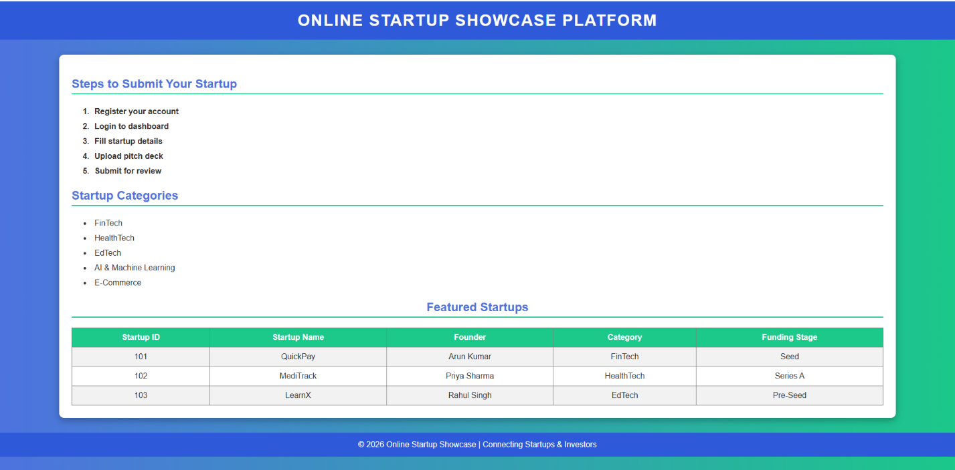

Program 2:
Index.html
<!DOCTYPE html>
<html>
<head>
<title>Startup Showcase</title>
<style>
body {
margin: 0;
font-family: Arial, Helvetica, sans-serif;
background: linear-gradient(to right, #667eea, #764ba2);
color: white;
}

header {
background: rgba(0,0,0,0.3);
padding: 20px;
text-align: center;
font-size: 28px;
letter-spacing: 2px;
}

nav {
text-align: center;
background-color: #ffffff;
padding: 15px;
}

nav a {
text-decoration: none;
color: #764ba2;
font-weight: bold;
margin: 20px;
font-size: 18px;
}

nav a:hover {
color: #ff4b2b;
}

.container {
width: 80%;
margin: 40px auto;
background-color: white;
color: black;
padding: 30px;
border-radius: 12px;
box-shadow: 0px 8px 20px rgba(0,0,0,0.4);
}

.features {
display: flex;
justify-content: space-around;
margin-top: 20px;
}

.card {
background: #f8f9fa;
width: 25%;
padding: 20px;
border-radius: 10px;
text-align: center;
box-shadow: 0px 4px 10px rgba(0,0,0,0.2);
}

.card:hover {
background: #ffe0f0;
transform: scale(1.05);
}

footer {
text-align: center;
padding: 15px;
background: rgba(0,0,0,0.4);
margin-top: 40px;
}
</style>
</head>

<body>

<header>
ONLINE STARTUP SHOWCASE PLATFORM
</header>

<nav>
<a href="login.html">Login</a>
<a href="catalogue.html">Catalogue</a>
<a href="register.html">Register Startup</a>
</nav>

<div class="container">
<h2>Welcome to the Startup Showcase</h2>
<p>This platform connects innovative startups with investors worldwide.</p>

<div class="features">
<div class="card">
<h3>🚀 Startup Listing</h3>
<p>Showcase your startup to investors.</p>
</div>

<div class="card">
<h3>💼 Investor Connect</h3>
<p>Meet angel investors and VCs.</p>
</div>

<div class="card">
<h3>📊 Funding Support</h3>
<p>Raise capital and scale faster.</p>
</div>
</div>
</div>

<footer>
© 2026 Startup Showcase | All Rights Reserved
</footer>

</body>
</html>

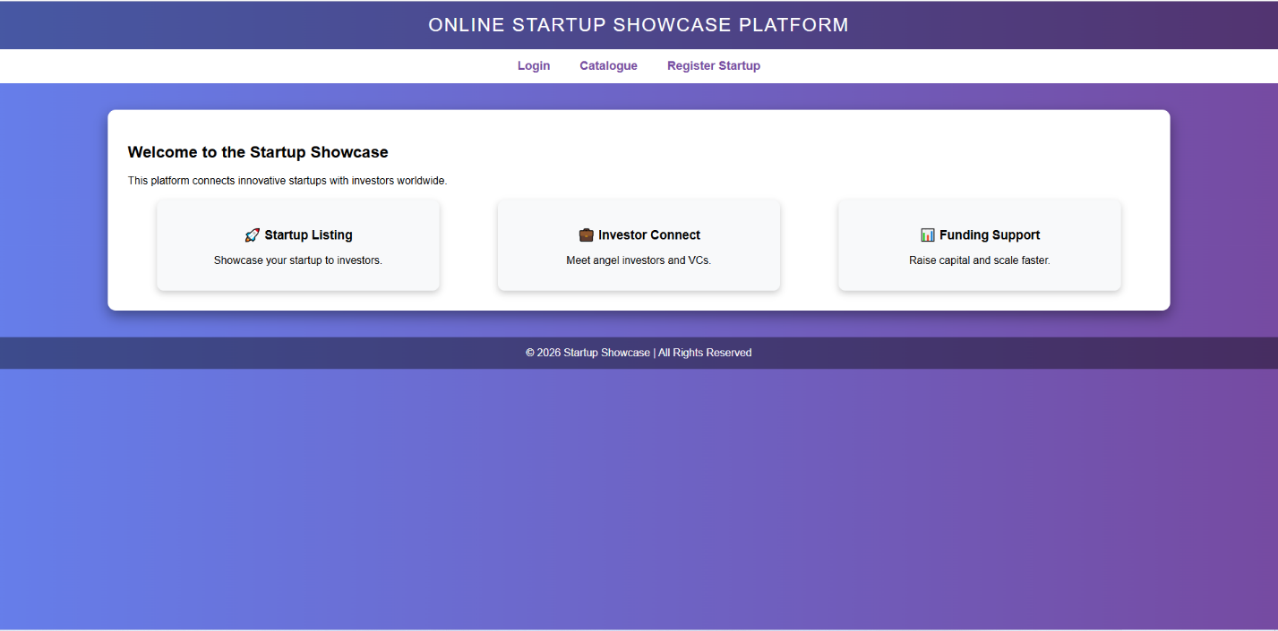

Login.html
<!DOCTYPE html>
<html>
<head>
<title>Login</title>
<style>
body {
font-family: Arial;
background: linear-gradient(to right, #ff512f, #dd2476);
display: flex;
justify-content: center;
align-items: center;
height: 100vh;
}

form {
background: white;
padding: 40px;
border-radius: 10px;
width: 300px;
box-shadow: 0px 8px 20px rgba(0,0,0,0.3);
}

h2 {
text-align: center;
}

input {
width: 100%;
padding: 10px;
margin-top: 10px;
}

button {
width: 100%;
padding: 10px;
margin-top: 15px;
background: #dd2476;
color: white;
border: none;
}
</style>
</head>

<body>

<form>
<h2>Login</h2>

<input type="text" placeholder="Username">
<input type="password" placeholder="Password">

<button>Login</button>

</form>

</body>
</html>

Menu.html
<!DOCTYPE html>
<html>
<body bgcolor="lightgray">
<h3>Menu</h3>
<ul>
<li><a href="home.html" target="mainframe">Home</a></li>
<li><a href="login.html" target="mainframe">Login</a></li>
<li><a href="catalogue.html" target="mainframe">Catalogue</a></li>
<li><a href="register.html" target="mainframe">Register Startup</a></li>
</ul>
</body>
</html>


Register.html
<!DOCTYPE html>
<html>
<head>
<title>Register Startup</title>
<style>
body {
font-family: Arial;
background: linear-gradient(to right, #11998e, #38ef7d);
display: flex;
justify-content: center;
padding: 40px;
}

form {
background: white;
padding: 30px;
border-radius: 10px;
width: 350px;
box-shadow: 0px 8px 20px rgba(0,0,0,0.3);
}

h2 {
text-align: center;
}

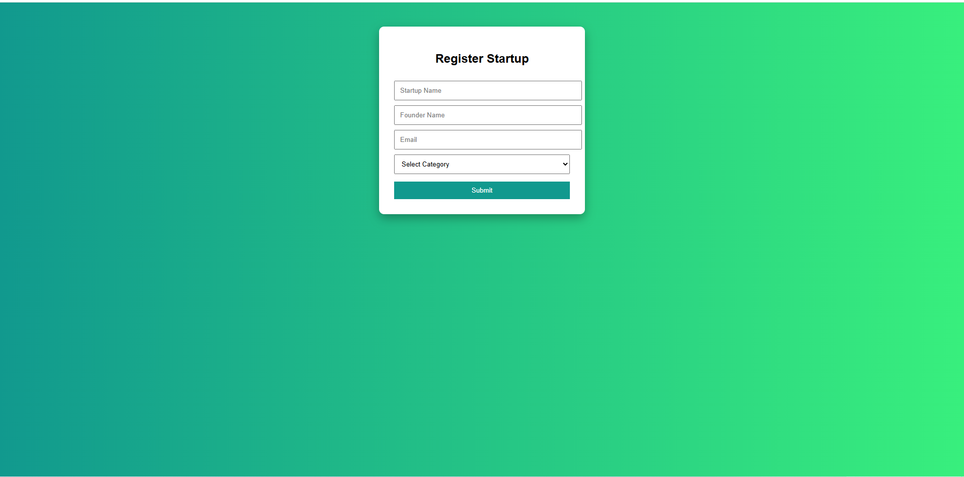
input, select {
width: 100%;
padding: 10px;
margin-top: 10px;
}

button {
width: 100%;
padding: 10px;
margin-top: 15px;
background: #11998e;
color: white;
border: none;
}
</style>
</head>

<body>

<form>
<h2>Register Startup</h2>

<input type="text" placeholder="Startup Name">
<input type="text" placeholder="Founder Name">
<input type="email" placeholder="Email">

<select>
<option>Select Category</option>
<option>FinTech</option>
<option>HealthTech</option>
<option>EdTech</option>
<option>AI</option>
</select>

<button>Submit</button>

</form>

</body>
</html>
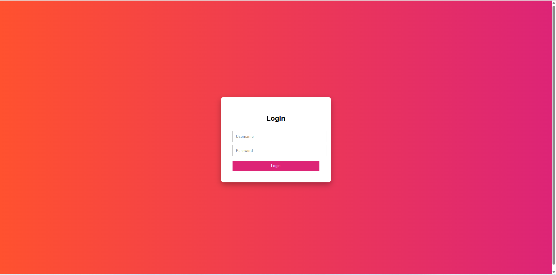
Top.html
<!DOCTYPE html>
<html>
<body bgcolor="darkblue" text="white">
<h1 align="center">ONLINE STARTUP SHOWCASE PLATFORM</h1>
</body>
</html>

Home.html
<!DOCTYPE html>
<html>
<body>
<h2>Welcome to Startup Showcase</h2>
<p>This platform helps startups connect with investors.</p>

<h3>Features:</h3>
<ul>
<li>Startup Listing</li>
<li>Investor Networking</li>
<li>Pitch Deck Upload</li>
<li>Funding Opportunities</li>
</ul>
</body>
</html>
Catalogue.html
<!DOCTYPE html>
<html>
<head>
<title>Startup Catalogue</title>
<style>
body {
font-family: Arial;
background: #f4f6f9;
text-align: center;
}

table {
width: 80%;
margin: 30px auto;
border-collapse: collapse;
}

th {
background: #764ba2;
color: white;
padding: 12px;
}

td {
padding: 10px;
}

tr:nth-child(even) {
background: #f2f2f2;
}

tr:hover {
background: #dcd6f7;
}
</style>
</head>

<body>

<h2>Featured Startups</h2>

<table border="1">
<tr>
<th>Name</th>
<th>Category</th>
<th>Founder</th>
<th>Funding Stage</th>
</tr>

<tr>
<td>QuickPay</td>
<td>FinTech</td>
<td>Arun Kumar</td>
<td>Seed</td>
</tr>

<tr>
<td>MediTrack</td>
<td>HealthTech</td>
<td>Priya Sharma</td>
<td>Series A</td>
</tr>

</table>

</body>
</html>
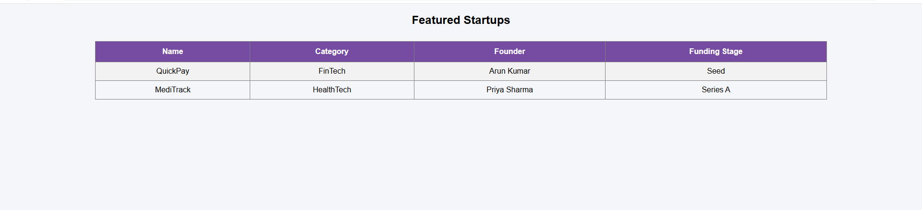

Program 3:
Index.html
<!DOCTYPE html>
<html>
<head>
<title>Startup Showcase Portal</title>

<style>
body {
margin: 0;
font-family: Arial, Helvetica, sans-serif;
background: linear-gradient(to right, #ff9966, #ff5e62);
}

/* Header */
header {
background: rgba(0,0,0,0.4);
color: white;
padding: 20px;
text-align: center;
font-size: 28px;
letter-spacing: 2px;
}

/* Navigation */
nav {
text-align: center;
background-color: white;
padding: 15px;
}

nav a {
text-decoration: none;
color: #ff5e62;
font-weight: bold;
margin: 20px;
font-size: 18px;
}

nav a:hover {
color: #333;
}

/* Iframe Section */
iframe {
width: 90%;
height: 420px;
margin: 30px auto;
display: block;
border: 5px solid white;
border-radius: 15px;
box-shadow: 0px 8px 20px rgba(0,0,0,0.4);
background-color: white;
}

footer {
text-align: center;
padding: 15px;
color: white;
}
</style>

</head>

<body>

<header>
ONLINE STARTUP SHOWCASE
</header>

<nav>
<a href="home.html" target="contentFrame">Home</a>
<a href="pitch.html" target="contentFrame">Startup Pitch</a>
<a href="contact.html" target="contentFrame">Contact</a>
</nav>

<iframe name="contentFrame"></iframe>

<footer>
© 2026 Startup Showcase | Innovation Hub
</footer>

</body>
</html>
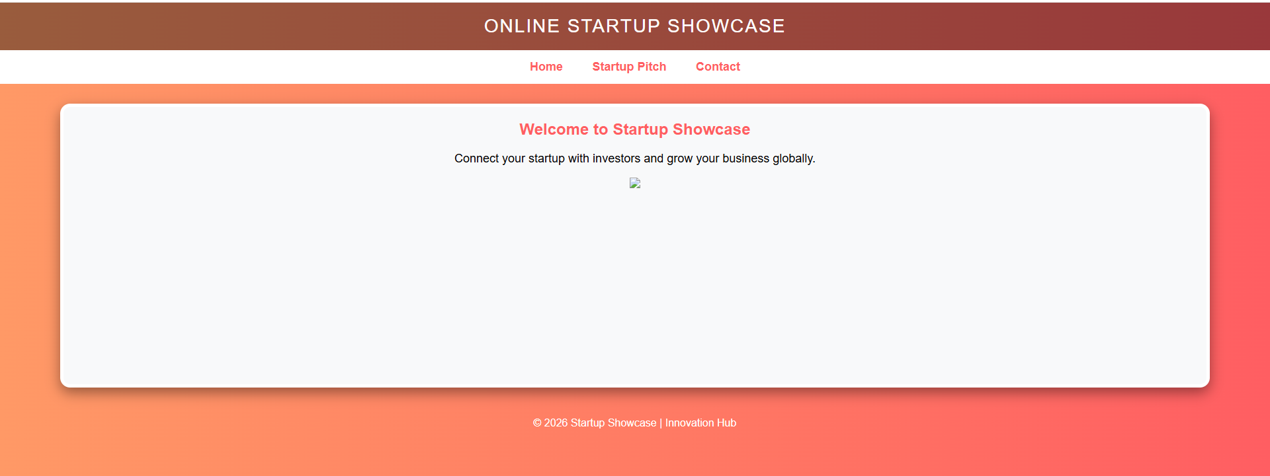

Home.html
<!DOCTYPE html>
<html>
<body style="font-family:Arial; text-align:center; background:#f8f9fa;">

<h2 style="color:#ff5e62;">Welcome to Startup Showcase</h2>

<p style="font-size:18px;">
Connect your startup with investors and grow your business globally.
</p>

<img src="https://via.placeholder.com/500x250?text=Startup+Innovation"
width="500">

</body>
</html>
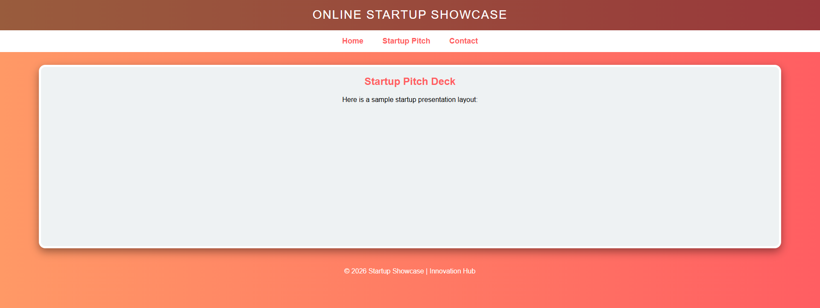
Pitch.html
<!DOCTYPE html>
<html>
<head>
<title>Startup Showcase Portal</title>

<style>
body {
margin: 0;
font-family: Arial, Helvetica, sans-serif;
background: linear-gradient(to right, #ff9966, #ff5e62);
}

/* Header */
header {
background: rgba(0,0,0,0.4);
color: white;
padding: 20px;
text-align: center;
font-size: 28px;
letter-spacing: 2px;
}

/* Navigation */
nav {
text-align: center;
background-color: white;
padding: 15px;
}

nav a {
text-decoration: none;
color: #ff5e62;
font-weight: bold;
margin: 20px;
font-size: 18px;
}

nav a:hover {
color: #333;
}

/* Iframe Section */
iframe {
width: 90%;
height: 420px;
margin: 30px auto;
display: block;
border: 5px solid white;
border-radius: 15px;
box-shadow: 0px 8px 20px rgba(0,0,0,0.4);
background-color: white;
}

footer {
text-align: center;
padding: 15px;
color: white;
}
</style>

</head>

<body>

<header>
ONLINE STARTUP SHOWCASE
</header>

<nav>
<a href="home.html" target="contentFrame">Home</a>
<a href="pitch.html" target="contentFrame">Startup Pitch</a>
<a href="contact.html" target="contentFrame">Contact</a>
</nav>

<iframe name="contentFrame"></iframe>

<footer>
© 2026 Startup Showcase | Innovation Hub
</footer>

</body>
</html>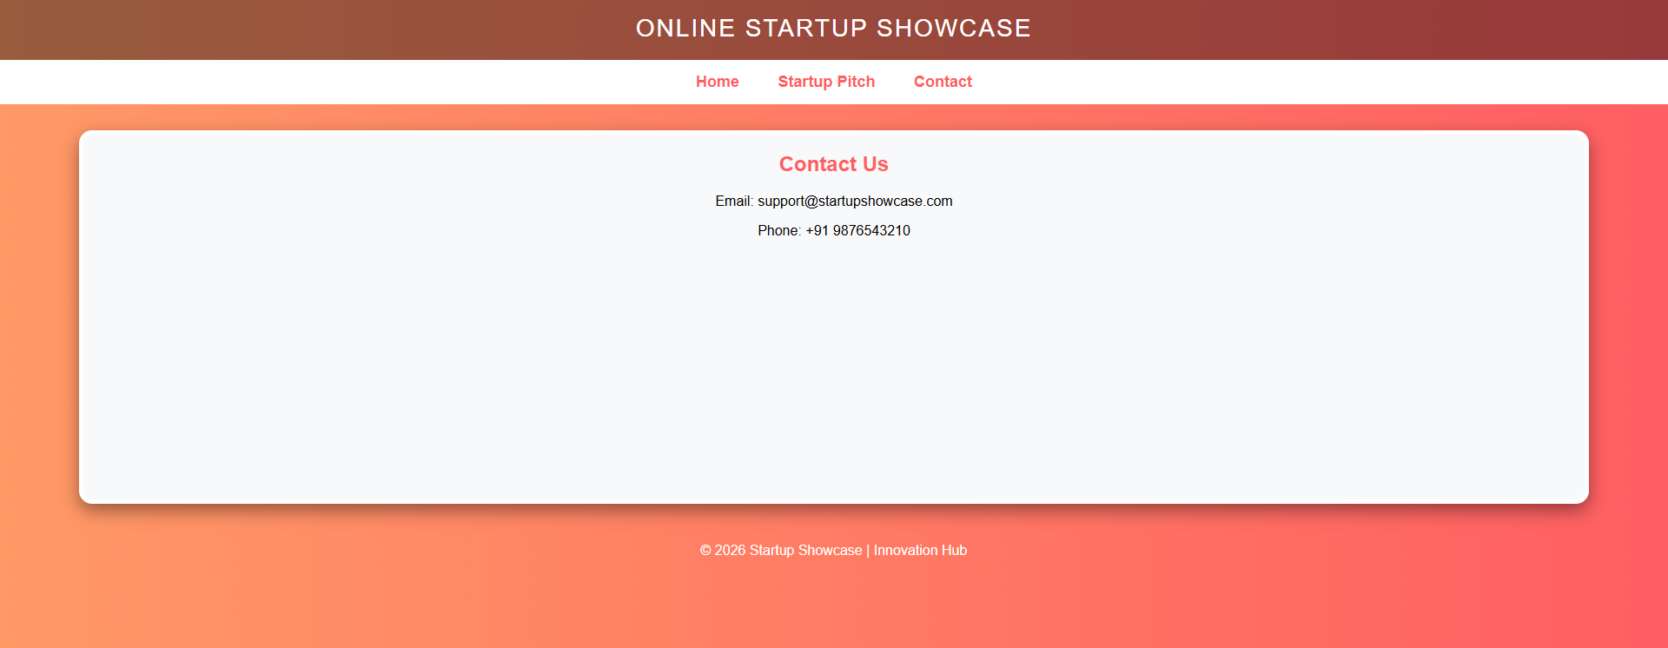

Contact.html
<!DOCTYPE html>
<html>
<body style="font-family:Arial; text-align:center; background:#f8f9fa;">

<h2 style="color:#ff5e62;">Contact Us</h2>

<p>Email: support@startupshowcase.com</p>
<p>Phone: +91 9876543210</p>

</body>
</html>

Program 4:
<!DOCTYPE html>
<html>
<head>
<title>Founder Registration Form</title>

<style>
body {
margin: 0;
font-family: Arial, Helvetica, sans-serif;
background: linear-gradient(to right, #4facfe, #00f2fe);
}

/* Main Form Container */
.container {
width: 450px;
margin: 50px auto;
background: white;
padding: 30px;
border-radius: 15px;
box-shadow: 0px 10px 25px rgba(0,0,0,0.3);
}

/* Heading */
h2 {
text-align: center;
color: #0077b6;
margin-bottom: 5px;
}

.subtitle {
text-align: center;
font-size: 14px;
color: gray;
margin-bottom: 20px;
}

/* Labels */
label {
font-weight: bold;
color: #333;
}

/* Inputs */
input[type="text"],
input[type="email"],
select,
textarea {
width: 100%;
padding: 10px;
margin-top: 5px;
margin-bottom: 15px;
border-radius: 8px;
border: 1px solid #ccc;
}

/* Radio Buttons */
.radio-group {
margin-bottom: 15px;
}

/* Buttons */
.button-group {
text-align: center;
}

input[type="submit"] {
background-color: #0077b6;
color: white;
padding: 10px 20px;
border: none;
border-radius: 8px;
margin-right: 10px;
}

input[type="reset"] {
background-color: #ff6b6b;
color: white;
padding: 10px 20px;
border: none;
border-radius: 8px;
}

input[type="submit"]:hover {
background-color: #023e8a;
}

input[type="reset"]:hover {
background-color: #d90429;
}
</style>

</head>

<body>

<div class="container">

<h2>Founder Registration Form</h2>
<p class="subtitle">Join our Startup Showcase Platform and connect with global investors</p>

<form>

<label>Full Name:</label>
<input type="text" placeholder="Enter your full name">

<label>Email Address:</label>
<input type="email" placeholder="Enter your email address">

<label>Phone Number:</label>
<input type="text" placeholder="Enter 10-digit phone number">

<label>Gender:</label>
<div class="radio-group">
<input type="radio" name="gender"> Male
<input type="radio" name="gender"> Female
<input type="radio" name="gender"> Other
</div>

<label>Address:</label>
<textarea rows="4" placeholder="Enter your address"></textarea>

<label>Startup Domain:</label>
<select>
<option>Select Domain</option>
<option>FinTech</option>
<option>HealthTech</option>
<option>EdTech</option>
<option>AI & Machine Learning</option>
<option>E-Commerce</option>
</select>

<div class="button-group">
<input type="submit" value="Submit">
<input type="reset" value="Clear">
</div>

</form>

</div>

</body>
</html>

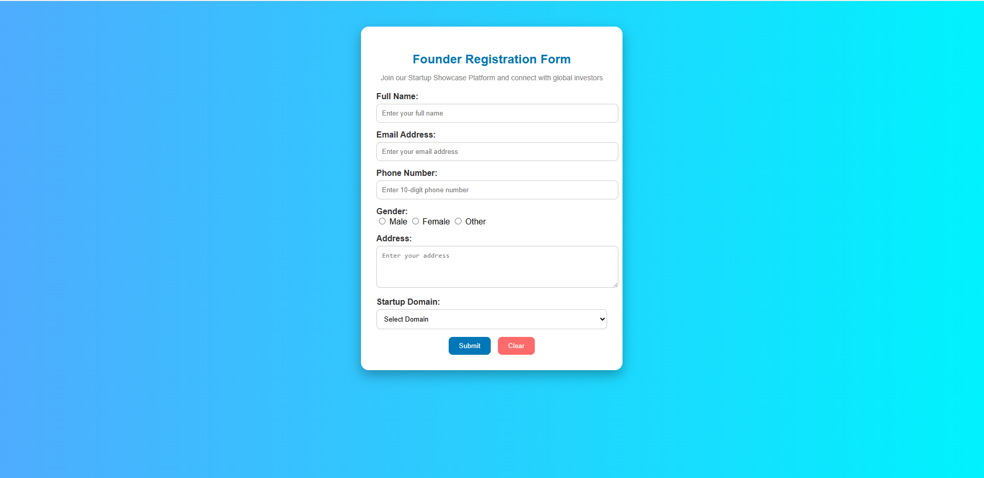

Program 5:
<!DOCTYPE html>
<html>
<head>
<title>Founder Registration | Startup Showcase</title>

<style>
body {
margin: 0;
font-family: Arial, Helvetica, sans-serif;
background: linear-gradient(135deg, #667eea, #764ba2);
}

/* Main Card */
.container {
width: 500px;
margin: 40px auto;
background: white;
padding: 30px;
border-radius: 15px;
box-shadow: 0px 12px 30px rgba(0,0,0,0.3);
}

/* Heading */
h2 {
text-align: center;
color: #5a189a;
margin-bottom: 5px;
}

.subtitle {
text-align: center;
font-size: 14px;
color: gray;
margin-bottom: 20px;
}

/* Section Title */
.section-title {
background: #f72585;
color: white;
padding: 8px;
border-radius: 6px;
margin-top: 20px;
font-size: 14px;
}

/* Labels */
label {
font-weight: bold;
color: #333;
display: block;
margin-top: 10px;
}

/* Inputs */
input[type="text"],
input[type="email"],
select,
textarea {
width: 100%;
padding: 10px;
margin-top: 5px;
border-radius: 8px;
border: 1px solid #ccc;
}

/* Radio */
.radio-group {
margin-top: 5px;
}

/* Info Text */
.info {
font-size: 12px;
color: gray;
margin-bottom: 5px;
}

/* Buttons */
.button-group {
text-align: center;
margin-top: 20px;
}

input[type="submit"] {
background-color: #4361ee;
color: white;
padding: 10px 25px;
border: none;
border-radius: 8px;
margin-right: 10px;
}

input[type="reset"] {
background-color: #ef233c;
color: white;
padding: 10px 25px;
border: none;
border-radius: 8px;
}

input[type="submit"]:hover {
background-color: #3a0ca3;
}

input[type="reset"]:hover {
background-color: #d90429;
}
</style>

</head>

<body>

<div class="container">

<h2>Founder Registration Form</h2>
<p class="subtitle">Register your startup and connect with investors globally 🚀</p>

<form>

<div class="section-title">Personal Information</div>

<label>Full Name *</label>
<p class="info">Enter your official name as per business registration.</p>
<input type="text" placeholder="John Doe" required>

<label>Email Address *</label>
<p class="info">We will use this email for investor communication.</p>
<input type="email" placeholder="example@email.com" required>

<label>Phone Number *</label>
<p class="info">Enter a valid 10-digit mobile number.</p>
<input type="text" placeholder="9876543210" required>

<label>Gender</label>
<div class="radio-group">
<input type="radio" name="gender"> Male
<input type="radio" name="gender"> Female
<input type="radio" name="gender"> Other
</div>

<label>Address *</label>
<textarea rows="3" placeholder="Enter your complete address" required></textarea>

<div class="section-title">Startup Information</div>

<label>Startup Domain *</label>
<p class="info">Select the primary industry of your startup.</p>
<select required>
<option value="">Select Domain</option>
<option>FinTech</option>
<option>HealthTech</option>
<option>EdTech</option>
<option>AI & Machine Learning</option>
<option>E-Commerce</option>
<option>AgriTech</option>
</select>

<label>Funding Stage</label>
<select>
<option>Pre-Seed</option>
<option>Seed</option>
<option>Series A</option>
<option>Series B</option>
<option>Bootstrapped</option>
</select>

<div class="button-group">
<input type="submit" value="Register Now">
<input type="reset" value="Clear Form">
</div>

</form>

</div>

</body>
</html>’
